Diabetes Classification – Data Analysis Report
1. Overview of the Project Domain
Diabetes is a chronic metabolic disease characterized by high blood glucose levels, which can result in serious long-term health complications if not detected and managed early. With the increasing availability of medical data, data analysis techniques are widely used to study patient health indicators and identify patterns associated with diabetes. This project belongs to the domain of healthcare data analytics and focuses on understanding patient characteristics and clinical measurements through exploratory data analysis and visualization.
2. Introduction to the Dataset
The dataset used in this project is a Diabetes Classification dataset containing demographic and medical information of patients. Each row represents an individual patient, and each column corresponds to a specific attribute such as age, gender, body mass index (BMI), cholesterol measurements, creatinine, blood urea nitrogen (BUN), and a diagnosis label. The diagnosis variable indicates whether the patient is diabetic or non-diabetic, making the dataset suitable for exploratory analysis aimed at understanding factors related to diabetes.
3. Description of the Problem or Questions Explored
The objective of this analysis is to explore the dataset and gain insights into the distribution of patient characteristics and their relationship with diabetes diagnosis. The analysis seeks to answer questions such as how age and gender are distributed among patients, whether BMI differs between diabetic and non-diabetic individuals, and whether there is a visible relationship between BMI and cholesterol levels. The focus of the project is on descriptive analysis and visualization rather than predictive modeling.
4. Data Cleaning Steps
Before conducting the analysis, the dataset was examined to ensure data quality and consistency. The dataset was loaded and its structure, dimensions, and data types were reviewed. Missing values were checked across all columns, and no significant missing data was identified. All variables were found to be in appropriate formats for analysis, and no major corrections or transformations were required. These steps ensured that the dataset was clean and ready for exploratory data analysis.

5. Dashboard Explanation and Insights
Figure 1: Age Distribution (Histogram)
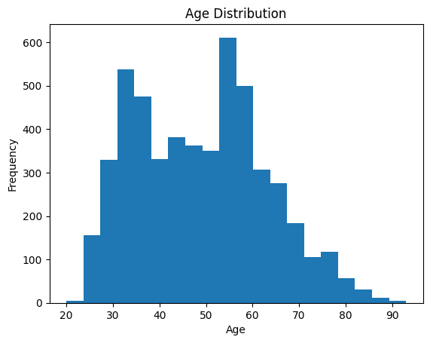
The histogram displays the distribution of patient ages in the dataset. It shows that the majority of individuals fall within the adult and middle-aged categories, with fewer patients at very young or very old ages. This visualization helps in understanding the age range covered by the dataset and highlights the most common age groups represented.
Figure 2: Gender Distribution (Bar Chart)
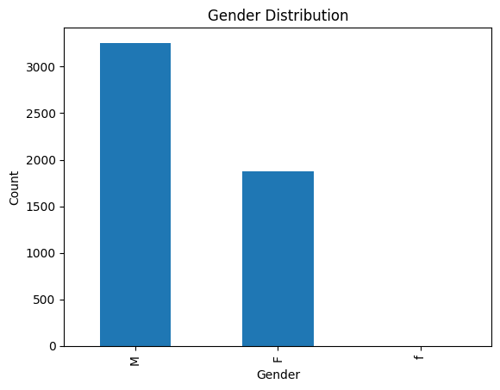
The bar chart illustrates the number of male and female patients in the dataset. This visualization provides a clear comparison of gender representation and helps determine whether the dataset is balanced in terms of gender. Understanding gender distribution is important when analyzing health-related outcomes such as diabetes.
Figure 3: BMI by Diabetes Diagnosis (Boxplot)
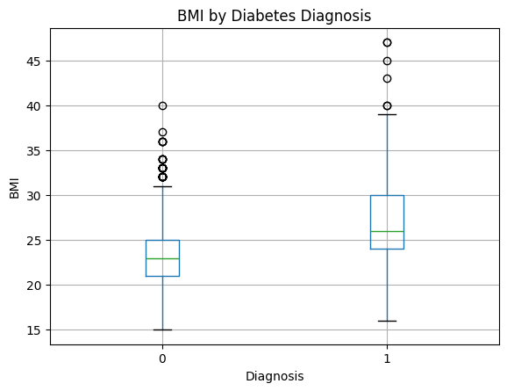
The boxplot compares BMI values between diabetic and non-diabetic individuals. It shows differences in the median and spread of BMI across the two groups. Diabetic patients tend to exhibit higher BMI values, suggesting that body mass index may be associated with diabetes risk. This visualization highlights variability and potential outliers within each group.
Figure 4: BMI vs Cholesterol (Scatter Plot)
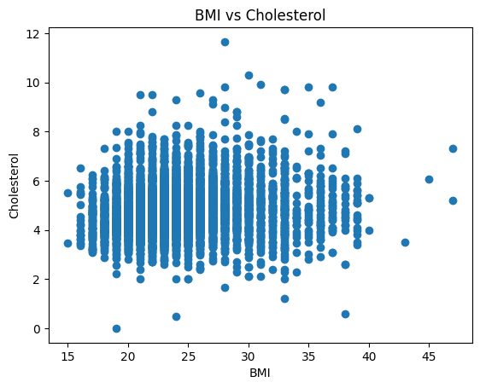
The scatter plot visualizes the relationship between BMI and cholesterol levels. Each point represents a patient, allowing observation of overall trends and clustering patterns. The plot suggests a possible positive relationship between BMI and cholesterol, indicating that higher BMI may be associated

References:
Dataset: https://www.kaggle.com/datasets/simaanjali/diabetes-classification-dataset

